An AI-Powered Voice Receptionist Framework for Smart Campus Communication and Information Access

¹Bhuvaneswaran B
Department of Computer Science and Engineering
Rajalakshmi Engineering College (Autonomous)
Chennai, India
bhuvaneswaran@rajalakshmi.edu.in

²Kamalesh S P
Department of Computer Science and Engineering
Rajalakshmi Engineering College (Autonomous)
Chennai, India
230701138@rajalakshmi.edu.in

³Akash N
Department of Computer Science and Engineering
Rajalakshmi Engineering College (Autonomous)
Chennai, India
230701019@rajalakshmi.edu.in

⁴Guru Raja T
Department of Computer Science and Engineering
Rajalakshmi Engineering College (Autonomous)
Chennai, India
230701502@rajalakshmi.edu.in

⁵Subramani A
Department of Computer Science and Engineering
Rajalakshmi Engineering College (Autonomous)
Chennai, India
230701347@rajalakshmi.edu.in

Abstract—Educational institutions receive many phone calls regarding admissions, departments, academic programs, courses, fees, placements, facilities, events, and other institutional in-formation. Such repeat calls can increase the work load for receptionists, increase the waiting time for callers and lead to inconsistency in the information given. Traditional systems for information access are based on websites or document-based interfaces and do not provide a natural voice-based interaction mechanism for telephone users. To address these issues, this paper proposes an AI voice-based receptionist system for smart college communication, by integrating real-time telephony, speech recognition, Retrieval-Augmented Generation (RAG) and a local Large Language Model (LLM). Real-time voice communication is pro-vided by the Asterisk telephony server, AudioSocket-based audio gateway and softphone-based caller interface. Incoming speech is processed and converted to text using Voice Activity Detection and Faster-Whisper. The identified query is then provided to a RAG pipeline to retrieve relevant institutional information using Sentence Transformers embeddings from a ChromaDB vector store. We pass the retrieved context to a Gemma 3:4B model, hosted locally via Ollama, to generate grounded and context-aware responses. This resulting response is then converted to natural speech using Piper TTS and sent back to the caller over the telephony pipeline. Direct RAG evaluation, RAGAS metrics and evaluation based on ARES were used to evaluate the system. The direct evaluation achieved 100.00% retrieval hit@5, 100.00% answer accuracy, and 100.00% negative refusal accuracy, and the RAGAS evaluation achieved 95.37% faithfulness, 92.31% context precision, and 100.00% context recall. The system offers a unified voice interaction framework for automated, consistent and knowledge grounded college information services.

Keywords—AI Voice Receptionist, Speech-to-Text (STT), Text-to-Speech (TTS), Retrieval-Augmented Generation (RAG), Large Language Model (LLM), Conversational AI, Voice Interaction.
- Introduction

Students, parents, visitors, and other stakeholders commonly place calls to educational organizations with regards to admissions, academic courses, departments,

charges, placements, facilities, events, rules, and student services, with most of these inquiries being repetitive, which leads to the increased work of receptionists, creates the possibility of inconsistent answers, and restricts help beyond normal work hours. The following solution can solve the existing limitations in the form of the development of an automated voice-based system, which would allow users to interact naturally via voice communication. Due to recent developments in the sphere of conversational artificial intelligence, voice-based systems became capable of recognizing the human speech and responding naturally due to Speech-to-Text (STT) models and Large Language Models (LLMs). However, the reliance on the LLM in terms of providing responses to voice-based interactions can result in the lack of grounding of these responses with the correct institution information, especially when it comes to academic policies, descriptions of courses, prices, and procedures. In order to overcome this problem, Retrieval-Augmented Generation (RAG) should be used. Unlike web-based/text-based chatbots, a voice receptionist needs to take into account the full communication process, which includes call receipt, audio processing, voice activity detection, speech recognition, knowledge retrieval, response generation, TTS synthesis, and delivering the answer back to the caller, as well as dealing with audio processing, latency problems, and reliable interactions between telephony and AI components. To meet these needs, in this paper we present an AI voice receptionist system for smart college communication by leveraging telephony automation capabilities with speech and language intelligence based on the Asterisk-based telephony architecture, a softphone interface, and AudioSocket for audio processing from the caller side. Incoming speech is processed through the audio gateway and voice activity detection, then transcribed using a Faster-Whisper model running locally, and sent to a RAG pipeline where Sentence Transformers are used for generating embeddings and ChromaDB is used as the vector store for institutional knowledge retrieval. The context retrieved in this manner is then fed to a locally deployed Gemma 3:4B model via Ollama in order to produce grounded responses that are subsequently translated into speech with the help of a TTS module and delivered back to the user through the telephony pipeline. The proposed system has been developed in such a way as to offer an automatic and consistent response to common college questions with minimum involvement of a live receptionist and formation of an integrated architecture encompassing telephony, speech recognition, semantic retrieval, local language model inference, and speech synthesis.

- Literature Survey
The appropriateness of voice-based AI frameworks and chatbots for different information search tasks was investigated by Rzepka, Berger and Hess [1]. In a laboratory experiment, the authors compared speech-based and text-based conversational agents using 116 participants. Results showed that voice assistants increased perceived efficiency, decreased cognitive effort, in-creased enjoyment, and increased service satisfaction for information search tasks. Also, the effectiveness of the interaction modality depends on the characteristics and goals of the in-formation search task. The authors concluded that voice-based and text-based conversational agents have different strengths per task at hand.

Radford et al., in [2], introduced a speech recognition model called Whisper which uses large-scale weak supervision during the training process. These models were trained using 680,000 hours of multilingual and multitasking audio data extracted from the web. In this work, these models are tested on several speech recognition and translation datasets. As a result, it is demonstrated that the obtained models have high robustness and generalization ability for different languages, accents, and speech settings. Also, it was shown that these models achieve human-level performance on a number of speech recognition benchmarks.

The authors of [3], Ao et al., have introduced a unified-modal encoder-decoder pre-training approach for spoken language processing tasks known as SpeechT5. It is based on using an encoder-decoder model where modality-specific pre-network and post-network are used for dealing with the speech and text. In order to create a common representation of speech and text, the authors suggested cross-modal vector quantization. We have tested SpeechT5 on automatic speech recognition, speech synthesis, speech translation, voice conversion, speech enhancement and speaker identification tasks.

Ren et al. proposed FastSpeech 2 [4], a non-autoregressive text-to-speech model, to overcome the limitations of the original FastSpeech model. The proposed method uses ground-truth speech information directly in training, as opposed to teacher-student distillation. Duration, pitch and energy information are added as conditional inputs in an effort to better represent the variations displayed in speech. The authors also proposed FastSpeech 2s which directly generates speech waveforms from text in parallel. The experiments show that FastSpeech 2 can speed up the training process by 3× compared with FastSpeech, and generate higher voice quality. The study showed that information of speech variation can be used to improve the quality and efficiency of synthesis.

In [5], Casanova et al. introduced YourTTS, which is an approach for multilingual zero-shot multi-speaker TTS and voice conversion. The approach relied on the VITS architecture adapted to multilingual and multi-speaker speech synthesis. The system obtained state-of-the-art performance in zero-shot multi-speaker TTS. Competitive results were also obtained for zero-shot voice conversion in terms of performance on the VCTK dataset. In addition, it was shown that the model can be fine-tuned using less than a minute of speech to obtain high voice similarity with decent speech quality.

Borgeaud et al. [6] proposed the Retrieval-Enhanced Trans-former (RETRO), a language model architecture that retrieves from a large external database at generation time. The model fetches relevant document chunks based on the previous input and merges the fetched information using cross-attention. It was trained on a data base of some two trillion tokens. RETRO matches the performance of much larger language models on a range of language modeling benchmarks while using far fewer model parameters. The study also showed improvements on knowledge intensive tasks after fine-tuning, showing external retrieval can provide useful knowledge to language models during generation.

In the research paper, Siriwardhana et al. [7], studied the application of the adaptation of the Retrieval-Augmented Generation model for open-domain question answering. The researchers have described the previous RAG models, which were trained on external knowledge mainly derived from Wikipedia and were not fine-tuned for any specific domain. They introduced RAG-end2end, an extension of the RAG model, for the joint training of the retriever and generator for the purpose of domain adaptation. We introduce another training signal that enables the model to retrieve sentences from a domain-specific external knowledge source and recreate those sentences.

[8] Gao et al. have done an extensive review of Retrieval-Augmented Generation in Large Language Models. In this review, the authors classified the development of RAG models into three main categories, namely Naive RAG, Advanced RAG, and Modular RAG. It discussed how to improve each part. It discussed challenges like hallucination, outdated knowledge, retrieval quality and evaluation. The authors also mention the capacity of RAG systems to combine external domain-specific and constantly updated knowledge with the internal knowledge of language models. This paper offers an in-depth survey of existing RAG techniques and future directions of research.

The paper Ram et al. [9] analyzed In-Context Retrieval-Augmented Language Models, whereby language models are conditioned on retrieved documents from an external corpus of grounding documents during the time of generation. The paper focused on studying retrieval augmented language modeling and how information retrieved can augment context of a language model. They use external documents as additional context, rather than forcing all the information to be contained within the parameters of the model. The study showed the efficacy of providing relevant retrieved information during generation, and that retrieval augmentation can lead to substantial gains in language modelling performance.

RAGTruth: Niu et al. [10] introduced a corpus for halluci-nation study of Retrieval-Augmented Generation systems. The authors observed that RAG models can produce unsupported or conflicting statements despite retrieving relevant information. RAGTruth contains nearly 18,000 naturally-generated responses from various large language models under RAG frameworks. Responses were manually annotated at the case and word level with information on the intensity of hallucination. The authors evaluated the hallucination rates of various language models and surveyed existing techniques for detecting hallucinations. The results showed that a relatively small fine-tuned language model could achieve competitive hallucination detection performance, and could also help re-duce hallucinations in generated responses.

Asai et al. [11] introduce the idea of Self-RAG, which incorporates the concepts of retrieval, generation, and self-reflection into one system, in order to enhance the factuality and quality of responses provided by the language model. The authors noted that in the traditional RAG setting, a set of certain number of passages is retrieved, which was unnecessary or irrelevant. Self-RAG enables the language model to conduct adaptive retrieval when necessary, and self-inspect the retrieved passages and generated responses through the use of reflective tokens. Experimental results for 7B and 13B models prove that Self-RAG is more effective than other language models and retrieval-augmented techniques in answering open domain questions, reasoning and fact verification tasks.

In [12], Jeong et al. proposed Adaptive-RAG, a framework that selects an appropriate retrieval strategy based on the complexity of the input question. They note that today’s retrieval-augmented language models may retrieve unnecessarily for simple questions, or may fail to properly handle complex multi-step questions. Adaptive-RAG addresses this problem by dynamically choosing between different strategies, from sim-ple language-model answering to retrieval-based approaches and more sophisticated multi-step retrieval. “The framework was built to understand the complexity of a question and choose a correct method. Experimental evaluation showed that adaptive retrieval strategies are effective to deal with questions with different levels of complexity.

In [13], Es et al. introduced RAGAs (Retrieval Augmented Generation Assessment), which is an assessment methodology for the evaluation of the performance of Retrieval-Augmented Generation pipeline, using a reference-free method. Three significant factors of the evaluation process are identified by the authors: the ability of the retrieval system to retrieve the relevant context, the ability of the language model to faithfully utilize the retrieved context and the generation performance of the response. RAGA provides a collection of evaluation metrics, that measure these factors without the necessity of manual preparation of the reference answers.

ARES, which stands for Automated RAG Evaluation System, was introduced by Saad-Falcon et al. in [14] for evaluating retrieval-augmented generation systems. This framework considers three dimensions in the evaluation: context relevance, answer faithfulness, and answer relevance. ARES creates synthetic training data for training language model judges that evaluate the components of RAGs. In order to make sure that ARES works more reliably in its evaluation, some human-annotated examples have been used for this purpose by prediction-based inference. ARES has been evaluated on eight knowledge-intensive tasks of KILT, SuperGLUE, and AIS.

In [15], Mahmood et al. investigated voice-based LLM models. The researchers developed a ChatGPT-powered Alexa skill and examined interactions across different scenarios. The study analyzed the different ways users interact with LLM-powered voice assistants and identified several types of conversational breakdowns. The findings showed that integrating ChatGPT improved intent recognition and enabled the voice assistant to proactively address some conversational breakdowns. The authors also discussed the benefits and challenges associated with using large language models in voice assistants and provided design considerations for developing future LLM-powered conversational voice assistants.

The studies reviewed show the effectiveness of voice inter-action, speech processing, retrieval-augmented generation and automated RAG evaluation. However, these technologies are often studied in isolation or in non-telephonic conversational settings. This leads to the requirement for a system that integrates real-time telephone communication, speech processing, retrieval of institutional knowledge, generation of grounded responses, and voice output for college information services.
- Proposed Method
The proposed system is the implementation of a voice-based AI receptionist to handle routine institutional information inquiries through a telephone interface. It uses speech processing, retrieval-augmented generation, a local large language model, and text-to-speech synthesis to produce voice responses. The telephony layer captures the speaker’s speech and then applies Voice Activity Detection and Faster-Whisper to convert speech to text. The transcribed query is processed and relevant institutional information is retrieved from the ChromaDB knowledge base using embeddings from sentence-transformers. The retrieved context is fed into the Gemma 3:4B language model to generate a context-aware response. The response is then converted to speech with Piper TTS and streamed back to the caller over Asterisk and AudioSocket. The overall workflow is oriented to support multi-turn conversation while restricting the answers to the knowledge that the institution has at disposal.

Pseudo Code Of The Proposed Method
Input: Caller voice query Output: Voice response Begin
- Initialize Asterisk, AudioSocket, VAD, Faster-Whisper, ChromaDB, embedding model, Gemma 3:4B, and Piper TTS.
- Receive incoming call from the caller.
- Establish bidirectional audio communication through AudioSocket.
- while call is active do
- Capture incoming 8 kHz PCM audio.
- Detect speech using WebRTC VAD.
- if speech is detected then
- Identify the complete user utterance.
- Convert speech to text using Faster-Whisper.
- Pre-process the transcribed query.
- Generate query embedding using Sentence-Transformers.
- Retrieve relevant document chunks from ChromaDB.
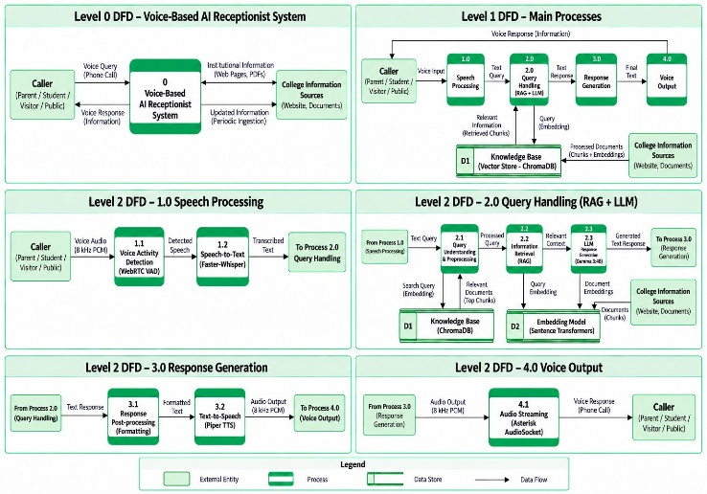
- if relevant institutional information is available then
- Provide retrieved context to Gemma 3:4B.
- Generate a context-grounded response.

else
- Generate a suitable refusal response.

end if
- Convert the response into speech using Piper TTS.
- Stream generated 8 kHz PCM audio through AudioSocket.
- Return the voice response to the caller.

end if
- end while
- Terminate the call.

End

  - Architecture Diagram
Fig. 1 illustrates the workflow of the proposed framework which is voice-based AI receptionist system. The architecture includes a caller and telephony layer, a voice processing and gateway layer, an intelligent agent layer, a knowledge base, and a response generation and voice output layer. These modules work together to receive a spoken query, retrieve relevant institutional information, generate a grounded response, and return the response to the caller in the form of speech.
The telephony layer captures the caller’s voice and passes it to the voice processing components. Speech-to-text converts the caller’s speech into text, which is then pre-processed for query handling. The knowledge base stores institutional information and retrieves relevant content using ChromaDB. The retrieved context is provided to the Gemma 3:4B LLM through the RAG module to generate a suitable response. The generated response is converted into speech using Piper TTS. Finally, the processed audio is streamed back through Asterisk and AudioSocket to complete the interaction.
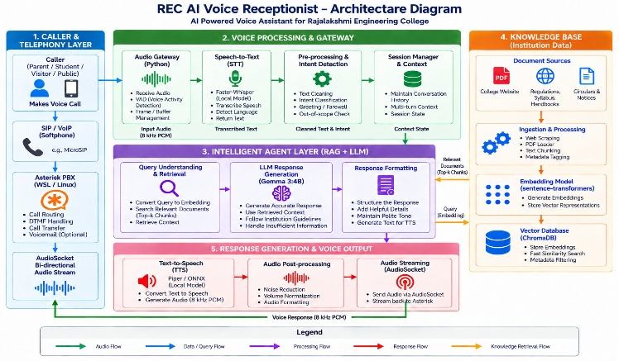
Fig. 1. Architecture of the proposed voice-based AI receptionist system

  - Data Flow Diagram
The Data Flow Diagram (DFD) shown in Fig. 2 illustrates the flow of information between the major processing stages of the proposed system. It represents the transformation of the caller’s voice query into a voice response through speech processing, query handling, response generation, and voice output processes.

Fig. 2. Data Flow Diagram of the proposed voice-based AI receptionist system

Voice Activity Detection and Faster-Whisper are used to detect and process the caller’s voice query. The resulting transcribed text is passed to the Query Handling module for pre-processing and retrieval. Sentence-Transformers embed-dings are used to retrieve relevant institutional information from the ChromaDB knowledge base. The response is then post-processed and converted into speech using Piper TTS. Finally, AudioSocket streams the generated voice response through Asterisk to the caller.

- Methodology
- Institutional Data Collection and Knowledge Base Preparation
The first step is to gather institutional information needed to answer routine college-related questions. The information has been gathered from publicly available sources of college like institution’s website, academic regulations, syllabus documents, circulars, notices and other relevant documents. The collected PDF and web content is extracted and transformed into text for proceeding further. The extracted information is di-vided into smaller pieces of text to increase retrieval accuracy and to reduce irrelevant information during query processing. Each chunk is embedded using Sentence Transformers embedding model so that it can be represented as a number in relation to its semantic content. The embeddings are generated and stored along with the text and metadata in a ChromaDB vector database. This is used as the institutional knowledge base of the proposed system to retrieve relevant information during a caller interaction.

- Voice Query Processing
The voice input is acquired when a caller makes a telephone call, through the Asterisk telephony server and AudioSocket-based audio gateway. The incoming audio is interpreted as 8 kHz PCM audio and processed with WebRTC Voice Activity Detection (VAD) to detect the start and end of speech segments. The detected speech is then fed into the speech recognition model Faster-Whisper for speech to text conversion. Thus, the transcription produced is the question of the caller and is passed to the query processing stage. The transcribed query is cleaned and prepared for semantic retrieval by performing basic text pre-processing. This process allows the system to convert natural telephone speech into a text-based query that is acceptable for the RAG pipeline.

- Query Retrieval and Response Generation
The transcribed query is embedded using the Sentence Transformers model and compared to the vector representations stored in ChromaDB. The system gets back the significant relevant chunks of documents based on the semantic similarity. We select the top five chunks as the candidates for retrieval. The retrieved institutional context is then sent to a locally hosted Large Language Model, Gemma 3:4B, via Ollama. The model generates a response with the retrieved information while respecting the institutional knowledge constraints. The response generation process is designed to avoid unsupported information, and to provide an appropriate refusal when the requested information is not present in the knowledge base. This response is then formatted into text and passed on to the text-to-speech stage.

- Voice Response Generation
The textual response generated is transformed into oral using the Piper text-to-speech model with a locally hosted ONNX voice model. The synthesized output is converted to 8 kHz PCM format, as required for telephone communication. This audio stream is then sent back to the Asterisk server via AudioSocket and delivered to the caller through the softphone interface. This completes the cycle of voice interaction, from the caller’s speech to an AI generated spoken response.

- System Evaluation
The efficiency of the proposed framework is evaluated by three complementary approaches: direct RAG evaluation, RA-GAS evaluation and ARES-based evaluation. Direct evaluation measures success in retrieval, correctness of answers, and the potential of the system to correctly refuse unsupported queries. The retrieved context and generated responses are evaluated by RAGAS in terms of performance metrics such as answer relevancy, context recall, faithfulness, and context precision to assess their quality. We also conduct an ARES-based evaluation based on context relevance, answer faithfulness and answer relevance which acts as extra evaluation of retrieval and response quality.
Retrieval Hit@5: Retrieval Hit@5 is defined as whether the relevant institutional information is among the top five document chunks returned by the RAG pipeline. We used 18 answerable test queries for evaluation.
Faithfulness: Verifies that the generated response is sup-ported by the retrieved institutional context and does not contain unsupported claims.
Answer Relevancy: Measures how appropriate and relevant the generated answer is to the caller’s question.
Context Precision: Quantifies the amount of relevant in-formation in the retrieved context for answering the given question.
Context Recall: Measures whether the retrieved context has the information to support the expected answer.
1) ARES Evaluation: An additional evaluation is performed inspired by ARES to give more assessment of the quality of retrieval and response. Similar to the RAGAS evaluation, for each metric, we report average scores across all queries evaluated.
  - Answer Accuracy: Answer Accuracy Percentage of answerable queries for which the generated response correctly provides the expected institutional information.
i
Context Relevance: The relevance of the retrieved context to the user query. The evaluation was conducted on 18 answerable test queries.
  - Negative Refusal Accuracy: Negative Refusal Accuracy is a metric that quantifies the system’s capability to accurately deny queries when the information requested is not found within the institutional knowledge base. This assessment was conducted with two unsupported queries. Number of correctly refused queries
Answer Faithfulness: Evaluates the faithfulness of the generated answer with respect to the retrieved context.
Answer Relevance: Evaluates how well the response answers the user’s question.
  - AGAS Evaluation: RAGAS evaluates the performance of a Retrieval Augmented Generation system with a suite of complementary metrics. Each metric yields a score between 0 and 1 for each test case. The overall score for each metric is the average of the scores obtained for all evaluated queries answer correctness, contextual grounding, and response qual-ity. The direct RAG evaluation used 18 answerable queries and 2 unsupported queries, while the RAGAS and ARES-inspired evaluations further evaluated the retrieval and generation stages.

- Results And Discussions
The proposed voice-based AI receptionist system was assessed by three complementary methods: direct RAG evaluation, RAGAS evaluation and ARES-inspired evaluation. These evaluations were conducted to evaluate retrieval effectiveness

- Direct RAG Evaluation
We present the outcomes of the direct RAG evaluation in Fig. 3. The Retrieval Hit@5 of the system was 100.00%, indicating that the relevant institutional information was retrieved in the top five document chunks for all the 18 answerable queries. The answer accuracy was also 100.00%, meaning that the generated responses correctly delivered the expected institutional information for all answerable queries tested. For the two unsupported queries the system achieved 100.00% negative refusal accuracy, demonstrating that it correctly re-fused to provide the information which was not available in the institutional knowledge base.

TABLE I. Direct RAG Evaluation Results

Evaluation Metric | Score (%)
Retrieval Hit@5 | 100.00
Answer Accuracy | 100.00
Negative Refusal Accuracy | 100.00

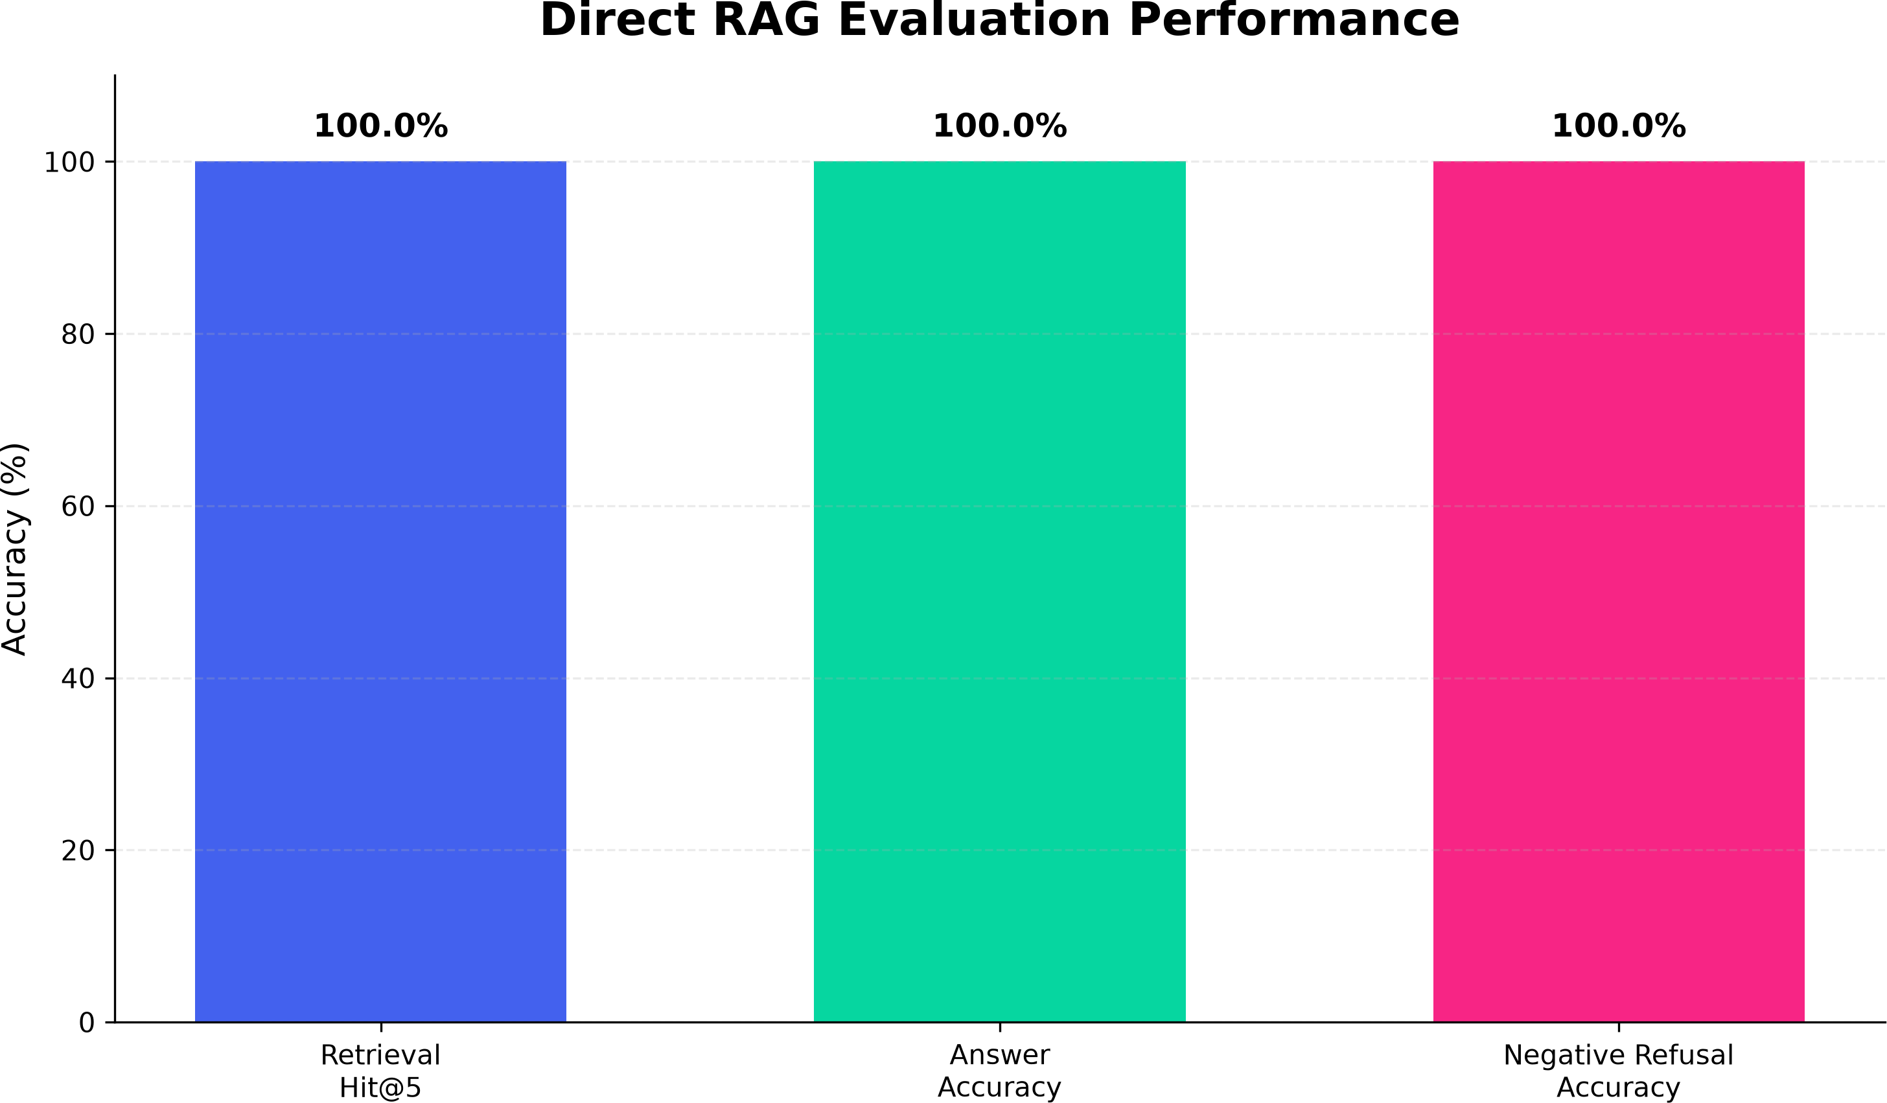

Fig. 3. Direct RAG evaluation performance

- RAGAS Evaluation

Fig. 4 shows the promising outputs of RAGAS of our proposed system. The system explicitly shows that 95.37% generated responses were mostly supported by the retrieved institutional context. The con-text precision was 92.31%, which indicates that majority of the information retrieved was relevant to the corresponding queries. Context recall was 100.00%, meaning the information needed to answer the evaluated answers was in the retrieved context. The answer relevancy score was 54.33% which is relatively lower than the other RAGAS metrics and shows room for improvement of the directness and formulation of the generated responses.
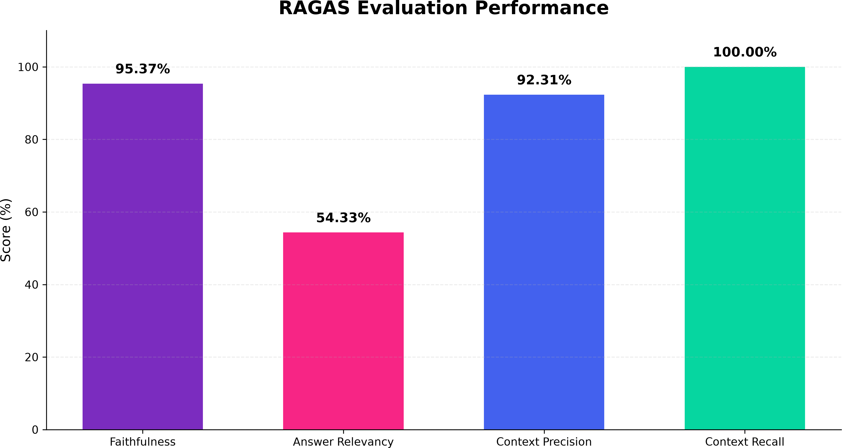
Fig.4. RAGAS Evaluation Performance

TABLE II RAGAS Evaluation Results

RAGAS Metric | Score (%)
Faithfulness | 95.37
Answer Relevancy | 54.33
Context Precision | 92.31
Context Recall | 100.00

- ARES-Inspired Evaluation

The findings based on the ARES evaluation are illustrated in Fig. 5. The obtained value for context relevance is 89.44%, meaning that most of the retrieved context is relevant to the user queries. As for answer faithfulness, its value is 95.83%, meaning that most of the generated answers are faithful to the context. The relevance score was 82.22%, which means that the answers were mostly relevant to the questions. These results provide further evidence that the proposed system preserves good alignment of user query, retrieved institutional context and generated response.

TABLE III ARES-Inspired Evaluation Results

Evaluation Metric | Score (%)
Context Relevance | 89.44
Answer Faithfulness | 95.83
Answer Relevance | 82.22
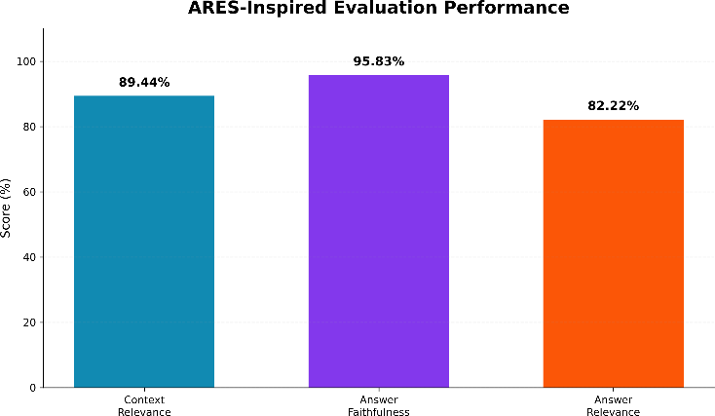
Fig. 5. ARES-inspired evaluation performance

- Overall Discussion
The results of the three evaluation approaches consistently proving its efficiency in retrieving and generating institution-specific information from the prepared knowledge base. The 100.00% Retrieval Hit@5 and answer accuracy obtained in the direct evaluation indicate reliable performance on the chosen test queries. The RAGAS evaluation also shows high faithfulness, context precision and context recall, confirming that the produced outputs are significant base for institutional information. The results motivated by ARES also achieve high context relevance and answer faithfulness. Although the RAGAS answer relevancy score is relatively lower, the results of the complementary evaluations indicate that the system provides useful and knowledge-grounded responses for the tested college-related queries.

- Conclusion

We propose a Voice-Based AI Receptionist Agent that offers an intelligent and efficient solution to common college-related questions through natural voice interaction. The system uses a real-time telephony pipeline along with Speech-to-Text, Retrieval-Augmented Generation, ChromaDB, Sentence Transformers, Gemma 3:4B, and Text-to-Speech technologies. We processed institutional information obtained from publicly available college sources into a knowledge base for similarity-based retrieval. The evaluation on 18 answerable questions got 100.00% Retrieval Hit@5 and 100.00% answer accuracy and negative queries got 100.00% refusal accuracy. RAGAS evaluation results showed 95.37% faithfulness, 54.33% answer relevancy, 92.31% context precision, and 100.00% context recall. The ARES-based evaluation achieved 89.44% context relevance, 95.83% answer faithfulness and 82.22% answer relevance. These results prove that the proposed system is robust for knowledge-grounded voice-based college communication. The system reduces the need for manual handling of repetitive inquiries and provides a practical basis for an automated AI receptionist.

VII. Future Works
In future work, the current system will be developed into a full AI receptionist with personalized and automated services. A major enhancement would be to connect the college ERP system with secure APIs to provide personalized data like attendance, internal marks, exam results, fee status and placement eligibility. Sensitive information will be protected by student verification via OTP or PIN based authentication and secure API communication. We will add support for Indian accents, multilingual and Tamil-English code-mixed queries, conversation history and faster response generation, making voice interaction more natural and responsive. Further development will be done to improve these aspects. Confidence based escalation can be used to pass complex queries to a human receptionist along with the conversation summary. Future evaluations could include larger sets of real-world queries, user satisfaction and longer voice interaction testing to evaluate the system in practical conditions of use. These improvements can develop the system into a scalable 24x7 voice-based college receptionist for general and personalized institutional communication.

References

- Rzepka, C., Berger, B., & Hess, T. (2022). Voice assistant vs. Chat-bot–examining the fit between conversational agents’ interaction modal-ities and information search tasks. Information systems frontiers, 24(3), 839-856.
- Radford, A., Kim, J. W., Xu, T., Brockman, G., McLeavey, C., & Sutskever, I. (2023, July). Robust speech recognition via large-scale weak supervision. In International conference on machine learning (pp. 28492-28518). PMLR.
- Ao, J., Wang, R., Zhou, L., Wang, C., Ren, S., Wu, Y., ... & Wei, F.(2022, May). Speecht5: Unified-modal encoder-decoder pre-training for spoken language processing. In Proceedings of the 60th annual meeting of the association for computational linguistics (volume 1: Long papers) (pp. 5723-5738).
- Ren, Y., Hu, C., Tan, X., Qin, T., Zhao, S., Zhao, Z., & Liu, T. Y. (2020). Fastspeech 2: Fast and high-quality end-to-end text to speech. arXiv preprint arXiv:2006.04558.
- Casanova, E., Weber, J., Shulby, C. D., Junior, A. C., Go¨lge, E., & Ponti, M. A. (2022, June). Yourtts: Towards zero-shot multi-speaker tts and zero-shot voice conversion for everyone. In International conference on machine learning (pp. 2709-2720). PMLR.
- Borgeaud, S., Mensch, A., Hoffmann, J., Cai, T., Rutherford, E., Millican, K., ... & Sifre, L. (2022, June). Improving language models by retrieving from trillions of tokens. In International conference on machine learning (pp. 2206-2240). PMLR.
- Siriwardhana, S., Weerasekera, R., Wen, E., Kaluarachchi, T., Rana, R., & Nanayakkara, S. (2023). Improving the domain adaptation of retrieval augmented generation (RAG) models for open domain question answer-ing. Transactions of the Association for Computational Linguistics, 11, 1-17.
- Gao, Y., Xiong, Y., Gao, X., Jia, K., Pan, J., Bi, Y., ... & Wang, H.
(2023). Retrieval-augmented generation for large language models: A survey. arXiv preprint arXiv:2312.10997.
- Ram, O., Levine, Y., Dalmedigos, I., Muhlgay, D., Shashua, A., Leyton-Brown, K., & Shoham, Y. (2023). In-context retrieval-augmented language models. Transactions of the Association for Computational Linguistics, 11, 1316-1331.
- Niu, C., Wu, Y., Zhu, J., Xu, S., Shum, K., Zhong, R., ... & Zhang, T. (2024, August). Ragtruth: A hallucination corpus for developing trustworthy retrieval-augmented language models. In Proceedings of the 62nd Annual Meeting of the Association for Computational Linguistics (Volume 1: Long Papers) (pp. 10862-10878).
- sai, A., Wu, Z., Wang, Y., Sil, A., & Hajishirzi, H. (2024, May). Self-rag: Learning to retrieve, generate, and critique through self-reflection. In International conference on learning representations (Vol. 2024, pp. 9112-9141).
- Jeong, S., Baek, J., Cho, S., Hwang, S. J., & Park, J. C. (2024, June). Adaptive-rag: Learning to adapt retrieval-augmented large language models through question complexity. In Proceedings of the 2024 confer-ence of the north american chapter of the association for computational linguistics: Human language technologies (volume 1: Long papers) (pp. 7036-7050).
- Es, S., James, J., Anke, L. E., & Schockaert, S. (2024, March). Ragas: Automated evaluation of retrieval augmented generation. In Proceedings of the 18th conference of the european chapter of the association for computational linguistics: system demonstrations (pp. 150-158).
- Saad-Falcon, J., Khattab, O., Potts, C., & Zaharia, M. (2024, June). Ares: An automated evaluation framework for retrieval-augmented generation systems. In Proceedings of the 2024 Conference of the North Ameri-can Chapter of the Association for Computational Linguistics: Human Language Technologies (Volume 1: Long Papers) (pp. 338-354).
- Mahmood, A., Wang, J., Yao, B., Wang, D., & Huang, C. M. (2025). User interaction patterns and breakdowns in conversing with LLM-powered voice assistants. International Journal of Human-Computer Studies, 195, 103406.

